Historical Context:
Imperialism has been interpreted from a variety of viewpoints. The documents below express various viewpoints about the positive and negative effects of European imperialism.
Task:
Use the following documents to evaluate both the positive and negative effects of Imperialism.

Section A Short Answer:
The documents below relates to the positive and negative effects of Imperialism. Examine each document carefully and then answer the question that follows it.
Document 1
O.P. Austin, "Does Colonization Pay" The Forum, 1900
"Modern progressive nations lying in the temperate zone seek to control garden spots’ in the tropics. [mainly in Africa, Latin America, and Asia] Under [the progressive nations] direction, these places can yield tropical produce. In return, the progressive nations bring to the people of those garden spots the foodstuffs and manufactures they need. [Progressive nations] develop the territory by building roads, canals, railways, and telegraphs. They can establish schools and newspapers for the colonies [and] give these people the benefit of other blessings of civilization which they have not the means of creating themselves."
- According to the author, what benefits did the colonies receive from the "modern progressive nations"?
________________________________________________________________________________________________________________________________________________________________________________________________________________________________________________________________________________________________________________________________________________________________________________________________________________________________________________________________________________________________________________________________________________________________________________________________________________________________________________________________________
Document 2
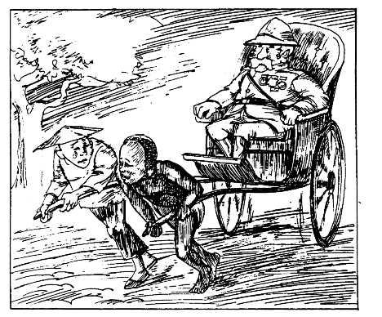
"Learning civilized ways is hard work"
- What did colonization mean for the native people?
________________________________________________________________________________________________________________________________________________________________________________________________________________________________________________________________________________________________________________________________________________________________________________________________________________________________________________________________________________________________________________________________________________________________________________________________

Document 3
"To begin with, there are the exporters and manufacturers of certain goods used in the colonies. The makers of cotton and iron goods have been very much interested in imperialism. Their business interests demand that colonial markets should be opened and developed and that foreign competitors should be shut out. Such aims require political control and imperialism.
Finally, the most powerful of all business groups are the bankers. Banks make loans to colonies and backward countries for building railways and steamship lines. They also make loans to colonial plantation owners, importers, and exporters.
The imperialist business interests have powerful allies. Military and naval leaders believe strongly in extending the white man’s rule over the ‘inferior races,’ To this company may be added another element—the missionary. Missionaries went forth to preach a kingdom beyond this world. But they often found themselves the builders of very earthly empires. . . . Last, but by no means least, let us add politicians to our list of empire builders."
Imperialism and World Politics, Parker T. Moore, 1926
- Who are the empire builders described in this passage?
_____________________________________________________________________________________________________________________________________________________________________________________________________________________________________________________________________________________________________________________________________________________________________________________________________________________________________________________________________________________________________________________________________________________________________________________________________________________________________________

Document 4
"When the whites came to our country, we had the land and they had the Bible, now we have the Bible and they have the land."
African proverb
- How did the Africans feel about the missionaries?
________________________________________________________________________________________________________________________________________________________________________________________________________________________________________________________________________________________________

Document 5
The White Man killed my father,
My father was proud.
The White Man seduced my mother,
My mother was beautiful.
The White Man burnt my brother beneath the noonday sun,
My brother was strong.
His hands red with black blood
The White Man turned to me;
And in the Conqueror’s voice said,
"Boy! a chair, a napkin, a drink.
An Anthology of West African Verse, David Diop, 1957
- What were some negative effects of imperialism in Africa?
__________________________________________________________________________________________________________________________________________________________________________________________________________________________________________________________________________________________________________________________________________

Document 6
"Colonialism’s greatest misdeed was to have tried to strip us of our responsibility in conducting our own affairs and convince us that our civilization was nothing less than savagery, thus giving us complexes which led to our being branded as irresponsible and lacking in self-confidence. . .
The colonial powers had assimilated each of their colonies into their own economy.
Our continent possesses tremendous reserves of raw material and they, together with its potential sources of power, give it excellent conditions for industrialization. . ."
Sekou Toure, West African nationalist, 1962
- In 1962, what was the response of this West African nationalist to years of colonialism?
________________________________________________________________________________________________________________________________________________________________________________________________________________________________________________________________________________________________
________________________________________________________________________________________________________________________________________________

Document 7
This German cartoon, published in the early 20th century, is entitled "Thus colonize the English."

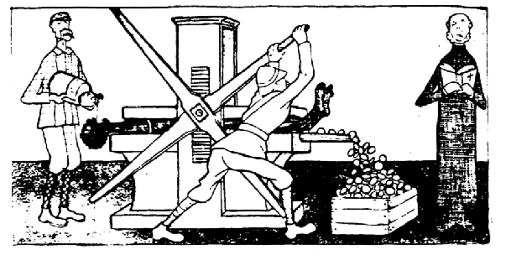
7. What is the point of view of this cartoonist about European imperialism?
________________________________________________________________________________________________________________________________________________________________________________________________________________________________________________________________________________________________________________________________________________________________________

Section B :Essay Response
Evaluate both the positive and negative effects of imperialism.
Your essay should be well organized with an introductory paragraph that states your position. Develop your position in the next paragraphs and then write a conclusion. In your essay, include specific historical details and refer to the specific documents you analyzed in Part A. You may include additional information from your knowledge of global history. Complete this part in your Social Studies notebook.

