Renaissance & Reformation Project
Directions: The Renaissance and Reformation were vital cultural movements that spanned across three centuries. During this time, literature, philosophy, the arts and sciences resulted in a “cultural rebirth” in Europe. Your job is to complete one of the following projects below.
Do you have ideas for alternative actives you would like to do instead? Talk them over with your teacher.
I prefer to do the following alternative activity: ________________________________
Date Due: Monday, October 2nd
PROJECT CHOICES

1) Hero Poster
Your Task: Create a Wanted/Hero poster for a figure from the Renaissance or Reformation. Your poster must be on large paper or poster board. It must be neat and show a great deal of effort. Sloppy or incomplete work will not be accepted.

Your poster must include:
Front:
1. The person’s name
2. A sketch of what the person looked like.
3. A written description of what the historical figure is known for (minimum 5 complete sentences)
4. Two made-up quotes from a person living during the time; detailing what people might have said about this person.
5. The approximate date this poster would have been found.
Back:
1. On the back, write a biography about your Renaissance person. It must include: where they were from, major contributions, family life and any interesting facts about them. Also, plagiarized (or work copied and pasted from the internet) will not receive credit. All work must be original. This can be neatly handwritten or typed. [Handwritten = 2 pages; typed = 1 page, 12 pt font, single-spaced.]

2) Time Machine
Your Task: Create a time machine, your time machine should include three (3) items that might have been found during the Renaissance/Reformation Era.
- In addition create a journal that would answer the following questions in 3-5 sentences each.
- What would a person like you spend most of his or her time doing in this civilization? (Would you be in school? What would you study there? Working? What job would you have? Playing? What games?)
- Draw or describe in words what clothing you would wear. (What would it be made out of? Do you think it would be comfortable?) → You may want to include a picture of what a teenager would wear.
- Describe some of the foods you would eat.
- Describe where would a person like you be living? (Would you be living with your family? With co-workers? With a husband or wife? What would your house be like?)
- Based on your answers and research, would you want to go back in time in this civilization? Why or why not?
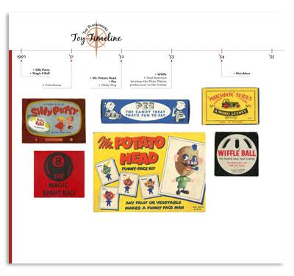
3) Illustrated/Annotated Timeline
Your task: Create a timeline of the Renaissance/Reformation that includes illustrations and captions highlighting key information. Your timeline should be neat and colored.

Your timeline must include:
- A minimum of 10 specific events that you want to represent on your timeline.
- A 3-4 sentence caption for each event along with the correct date when it occurred.
- A picture for all of the events represented on your timeline.

4) Model or Artwork
Your Task: Show off your artistic and creative side by re-creating a famous work of art (painting or sculpture) from the Renaissance or Reformation era.
- Your artwork must be school appropriate. Art from the Renaissance era was obsessed with the human body, but please make it school appropriate. You are allowed to use half of an image or statue to recreate. Ex.—If you want to sculpt the statue of David, you may sculpt his hand or his face. Use your best judgment.
- After you have created your piece of artwork, write a detailed three paragraph summary.
  - Paragraph One: Background of the artist
  - Paragraph Two: Why was the artist important to the Renaissance?
  - Paragraph Three: Describe the artist’s piece of work that you have created. You may want to include the details that the artist included or the symbolism that is present in the work.

