RISE OF DICTATORS: Dictators PowerPoint Project

The book is due on Monday, March 30th and is worth a FORMAL PROJECT GRADE.

Your book MUST include:
- Cover Page
- Page1:Key Traits of Totalitarianism graphic
- 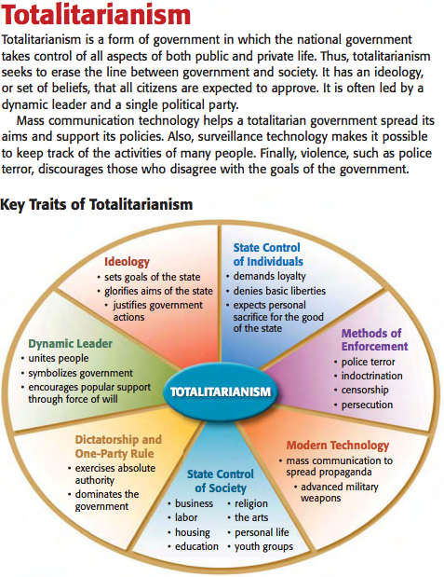
- Page 2: Table of Contents:
- Your project must include these dictators past and present: Adolf Hitler, Benito Mussolini, Joseph Stalin, Kim Jong Un, Muammar al- Quaddafi, Idi Amin Dada, Bashar al-Assad, Vladimir Putin

These steps are to be followed for EACH dictator:
- Name of Dictator (be sure to include “nickname”, if any)
- A Picture of each dictator studied
- Answers to the following questions [answers are to be in complete sentences; do not plagiarize]:
  - Which country did the Dictator rule over?
  - What was the timeframe of his rule? (beginning and ending years)
  - How did the Dictator come to power? Discuss in detail.
  - In what country was the Dictator born?
  - What type of education did the Dictator have?
  - Describe, if any, the type of military experience the Dictator had?
  - Describe the Dictator’s ruling style, i.e., was he a totalitarian, fascist, communist, etc.?
  - How did the public/citizens react toward the ruler?
- An actual quote from the dictator. Then, in your own words, explain the meaning behind the quote.
- Your opinion of the dictator (must be at least 5 complete sentences).

RISE OF DICTATORS: Book of Dictators- In Class Project
RUBRIC

 | Total  Pts Possible | Adolf Hitler  Kim Jong Un | Emperor Hirohito  Muammar al- Quaddafi | Benito Mussolini  Idi Amin Dada | Josef Stalin  Bashar al-Assad  , Vladimir Putin
Cover Page | 4 points
What if you ruled chart | 12 points
Key Traits of Totalitarianism | 12 points
Name EACH of Dictator | 8 points
Picture of EACH Dictator | 8 points
Answers to all 8 questions for EACH dictator | 64 points
Quote with interpretation for EACH dictator | 8 points
Opinion of EACH Dictator | 8 points
Total Points Possible | 124 points

For extra credit I will give you a free homework pass for any dictator added additionally to this list. Here is a site with a list of dictators. {Limit 5}
https://www.conservapedia.com/List_of_dictators

