Scientific Revolution Trading Cards
Create a set of trading cards (for all 9 scientists listed below) on index cards, printer paper or construction paper representing their major achievements during the Scientific Revolution. Due Date on Monday 10/14/19. The majority of this assignment will be done in class.
  - Francis Bacon
  - Nicolaus Copernicus
  - Isaac Newton
  - Galileo Galilei
  - Johannes Gutenberg
  - Johannes Kepler
  - Adreas Vesalius
  - Antonie Van Leewenhoek
  - Antonie Lavoisier

Links to help you research the scientists→
- http://www.sciencekids.co.nz/videos/famousscientists.html
- http://www.ducksters.com/biography/scientists/scientists_and_inventors.php
- http://mrnussbaum.com/all-biographies/
Trading Card Procedures & Requirements
EACH card MUST contain ALL of the following:
Front of card:  - Name of scientist  - Date of birth & date of death  - Country  - Type of scientist (astronomer, mathematician, etc.)  - Hand-drawn, full-color, high quality illustration of the scientist | Back of card:  - At least 2 major achievements/philosophies/ideas  - At least 2 quotes  - At least 2 major published materials or other important works  - Any other interesting information about the scientist, their life, or their work  - Created by: (your name)

- Use note cards, construction paper, printer paper
- Each individual will create 9 cards
- Use colored pencils, markers, crayons, , etc. to create colorful, high-quality cards that contain all of the information listed in the requirements
- Accuracy, importance of facts chosen, and creativity will be part of your grade (see grading rubric)
Scientists Trading Card Project Grading Rubric
 | 4 | 3 | 2 | 1-0
Front of Cards: Information | Complete & contains all required elements (name, dates, country, type of scientist, illustration); accurate, relevant & factual information | Nearly complete & contains most required elements (name, dates, country, type of scientist, illustration); accurate & factual information | Incomplete & contains some required elements (name, dates, country, type of scientist, illustration); inaccurate information | Incomplete & contains little to no required elements (name, dates, country, type of scientist, illustration)
Front of cards: Quality and creativity | Hand-drawn, full-color, high quality illustrations; high-quality, relevant information; well-organized and excellently presented | Nearly complete, hand-drawn, color illustration; accurate & factual information and quotes; organized and presented nicely | Incomplete illustrations, lacking color and quality; and/or inaccurate information; poorly organized | Incomplete and contains little to no accurate information and/or quotes; very poorly organized
Back of cards: Information | Complete & contains all required elements (achievements, quotes, published works, interesting info., # of scientist, and creator’s name); accurate, relevant & factual information | Nearly complete & contains most required elements (achievements, quotes, published works, # of scientist, and creator’s name); accurate & factual information | Incomplete & contains some required elements (achievements, quotes, published works, # of scientist, and creator’s name); inaccurate information | Incomplete & contains little to no required elements (achievements, quotes, published works, # of scientist, and creator’s name)
Back of cards: Quality and creativity | Complete, high quality, relevant information and quotes; well-organized and excellently presented; additional interesting information | Nearly complete, accurate & factual information and quotes; organized and presented nicely | Incomplete and/or inaccurate information and quotes; poorly organized | Incomplete and contains little to no accurate information and/or quotes; very poorly organized

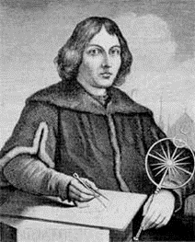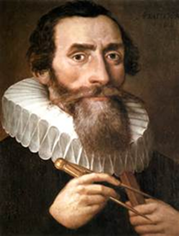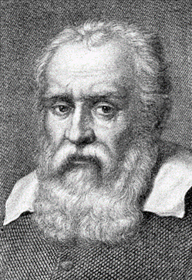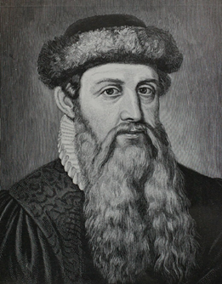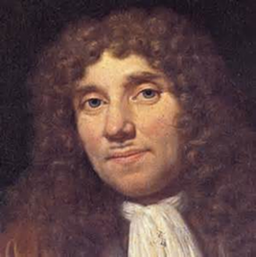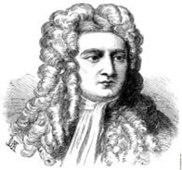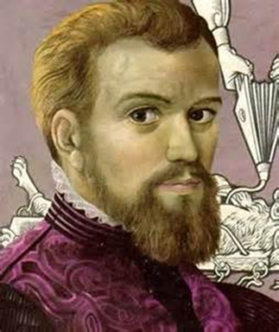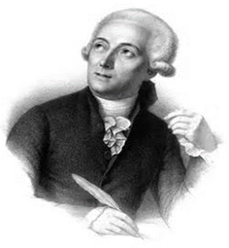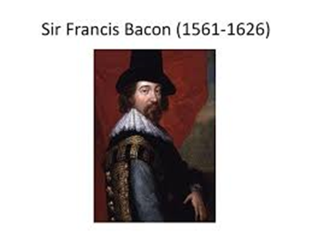

Lavoisier

