The Age of Exploration (also called the Age of Discovery) began in the 1400s and continued through the 1600s. It was a period of time when the European nations began exploring the world. They discovered new routes to India, much of the Far East, and the Americas. The Age of Exploration took place at the same time as the Renaissance. ←Summarize this paragraph in 5 words. Does not have to be complete sentences.

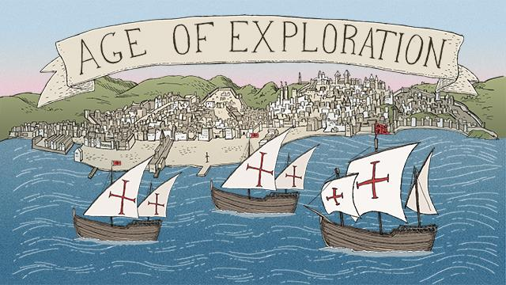

Using the web address below, read and learn about the explorers and how they had such an impact on history.

http://www.ducksters.com/history/renaissance/age_of_exploration_and_discovery.php

WebQuest - The Age Of Exploration

While reading the passage, answer the following questions to establish background information on the Age of Exploration.

1. Exploring was expensive and risky. Why did Europeans want to explore?

2. List three ways expeditions could make money.

3. Where did the Age of Exploration begin?

4. What did Henry the Navigator do and what was the result of his actions.
5. In 1488, what did the Portuguese explorer Bartolomeu Dias do?

6. What country did Christopher Columbus sail for and why?

7. Which two countries were the early leaders in the Age of Exploration?

8. Through the Treaty of Tordesillas the Spain and Portugal agreed to
divide up the New World. What did each country gain from the treaty?

9. Name the two conquistadores Spain sent to America and who they each conquered.

10. Who did Portugal send out to explore? What did they gain from his exploration?

11. Eventually which country would surpass all of the European nations in terms of the size of their world wide empire?

12. Which country founded the thirteen American colonies that later became the United States?

13. Who led the first expedition to circle the globe?

14. What area of the world was still not mapped at the end of the Age of Exploration?

Final Step: Look at the bottom of the web page and find the sentence below.
“Take a ten question quiz at the Age of Exploration questions page”
Use the link to take the 10 question quiz. Take a screenshot of your score (ctrl+alt+prt scr) and paste it below. Correct any questions you got wrong.

